WiMDA Manual

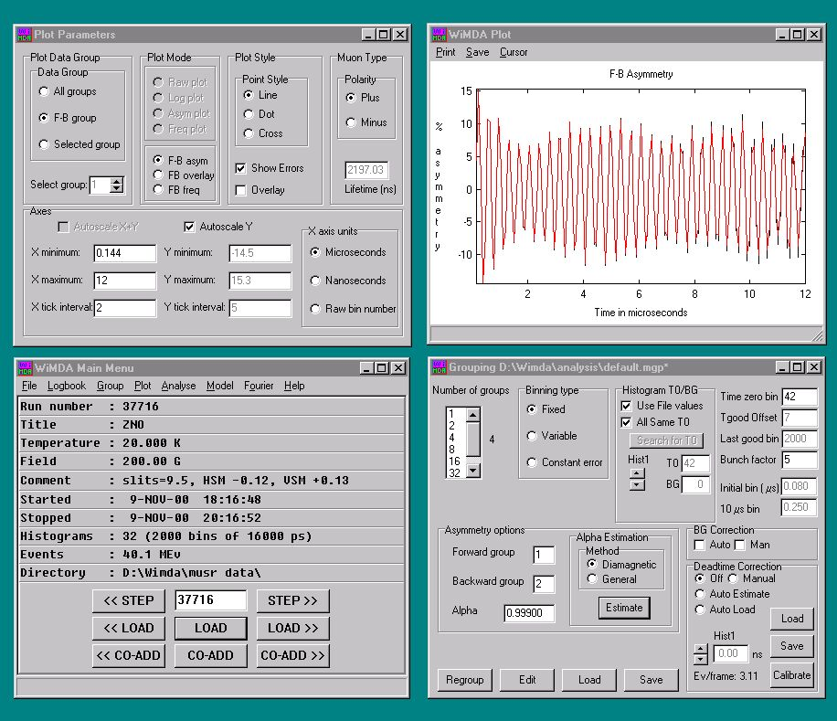

Marianne Lynch, Francis Pratt, Steven Cottrell. Philip King

Windows Muon Data Analysis

The function of WiMDA is to analyse and display the data collected from μSR experiments. As a Windows-based application, WiMDA is designed to be convenient and easy to use on the most universally available computing platform. The program enables an experimenter to work with their data both during and after their experiment, to view the data, to fit the data to a standard and user programmed models, to plot fit parameters, and, if required, to perform frequency spectrum analysis.

Although WiMDA is designed to work with data originating from many different muon sources, the emphasis of this manual is mainly on the use of WiMDA with ISIS data. However, some additional features related to PSI, KEK and TRIUMF data are partly covered.

The WiMDA data analysis programme was written by Francis Pratt. Any comments or suggestions about the WiMDA programme or this manual should be emailed to francis.pratt@stfc.ac.uk

WiMDA Manual
February 2005
Version 1.2

Table of Contents

1. Getting Started. 7
1.1 Obtaining and installing WiMDA 7
2. Running WiMDA 8
2.1 Main Menu 8
3. File 10
3.1 Open 10
3.2 Save/ Save as 10
3.3 Load fit Libraries 10
3.4 Printer set-up 10
3.5 Co-sub mode 10
3.6 Setup 11
3.7 Generating test data 13
4. Logbook 14
5. Grouping 15
5.1 Standard groupings 16
5.2 Alpha 17
5.3 How Alpha is calculated 17
5.4 Binning 17
5.5 T zero offset 18
5.6 T good offset 18
5.7 Bunching factor 18
5.8 BG (background) correction 18
5.9 Deadtime correction 19
5.10 Group T0/BG 19
5.11 Binning and Binning type 19
6. Plot 20
6.1 WiMDA plot window 20
6.2 Plot parameters window 21
7. Analysis 23
7.1 Analysis window 23
7.2 Standard Oscillation Functions 24
7.3 Standard Relaxation Functions 24
7.4 Group to Fit 25
7.5 Asymmetry and Relaxation Components 27
7.6 Batch Fit 28
7.7 Other functions 29
7.8 Baseline Relaxation 30
7.9 Linking 30
7.10 Fit Table 31
7.11 Fit Log 32
8. Model 34
8.1 Data Set Modelling 35
8.2 Model Plot 35
8.3 GLE Window 36
9. Fourier 37
10. Using WiMDA to analyse PSI data 39
11. Example Experiments 40
11.1 Example experiment 1: Longitudinal Fields 40
11.2 Example experiment 2: Transverse Fields 45
Appendices 48
A. Alpha calculation 48
B. Deadtime correction 48
C. Standard Fit functions 49
D. Writing Custom WiMDA Functions 50

1. Getting Started.

1.1 Obtaining and installing WiMDA

WiMDA can be downloaded from the WiMDA web site http://shadow.nd.rl.ac.uk/wimda

Installation instructions can also be found on this site.

2. Running WiMDA

2.1 Main Menu

The following data is displayed in the dialogue box.

Run Number file name
Title title allocated by the user.
Temperature mean average experimental temperature in Kelvin. This value can either be taken from the temperature log from the label stored in the file or entered by the user by selecting the appropriate option from the Options sub menu in the Fit Table (see Analysis section 7.10)
Field magnetic field value during experiment as entered by user in Gauss
Comment notes made by the user, often sample type.
Started date and time run started
Stopped date and time run finished.
Histograms number of histograms in the file, each detector has its own histogram. The number of bins and the time resolution of each histogram is also shown.
Events total number of positrons detected in millions of events
Directory root directory from which the files are being loaded

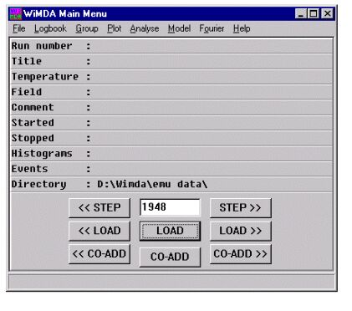
Figure 2.1 WiMDA Main Menu
A different file can be viewed by either clicking on STEP, LOAD or typing the run number into the field. STEP>> or <<STEP increase or decrease the run number by 1 without loading a file. LOAD>> or <<LOAD increase or decrease the run number by 1 and then load the corresponding data file. LOAD loads in the run number that is in the dialogue box.

CO-ADD allows the user to add together the data in of two or more runs. An average result weighted by the number of events in each run in produced. CO-ADD>> or <<CO-ADD add together the present run with the run number one higher or lower. CO-ADD adds the current run to the next run number to be entered into the dialogue box.

3. File

3.1 Open

Opens desired file for WiMDA analysis. When the file is opened
WiMDA saves the file location and filename format details as defaults in the set-up file.

3.2 Save/ Save as

Creates an ASCII file containing the results produced by WiMDA. E.g. if a plot of
asymmetry versus time was produced a file containing the times and corresponding
values of asymmetry would be created. If the plot was fitted then the fit values can also
be saved.

3.3 Load fit Libraries

Specifies the directory where the libraries of fit functions are to be loaded from and loads them.

3.4 Printer set-up

Allows printer options to be chosen e.g. which printer to use or whether to print portrait
or landscape documents

3.5 Co-sub mode

This switches the co-add function to co-subtract. Allows one run to be subtracted from
another. This is usually used if e.g. an experiment is left to run until 10 million events are recorded and then stopped. Then the same experiment is left running until 20 million results are recorded. The 10 million event run could be subtracted from the 20 million event run to obtain the results of the experiment between 10 and 20 million events.

3.6 Setup

Clicking on setup brings up two setup windows. One is in the style of a form and the other is a text editor interface for the wimda.ini setup file.

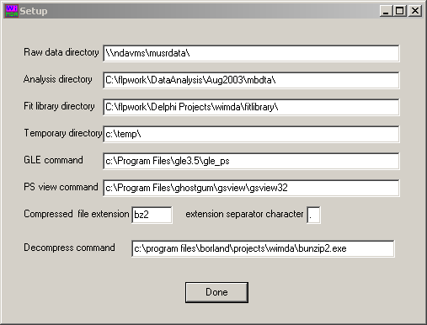

Figure 3.1. WiMDA form-style setup window

The form-style window has the following fields:

Raw data directory directory in which WiMDA will search for muon data files. The directory name is displayed in the main menu window

Analysis directory working directory for analysis, i.e. where files containing the fit logs, fit tables etc. will be written

Fit library directory directory from which fitting libraries are loaded

Temporary directory directory in which temporary files are stored

GLE command command to invoke GLE to generate a postscript plot of model fitting results
PS view command command which runs ghostview to view the postscript files generated by GLE
Compressed file extension any raw data file with this extension will be decompressed automatically by WiMDA, usually bz2

Extension separator character separator for the compressed file extension, usually the full stop

Decompress command the decompression process that WiMDA will perform, usually bunzip2.exe

Further entries are stored in the wimda.ini setup file, e.g. the run prefix, number, separator and extension, number of digits in the run number and the compression status of the last file loaded. At ISIS the prefix is either ‘r’ or the machine used for the experiments e.g. ‘emu’, ‘musr’, ‘mut’ or ‘argus’; the run number is a five to eight digit number, the separator is a full stop and the extension is either ‘ral’, ‘nxs’ or ‘macs’. This information is extracted automatically when a run is loaded successfully into WiMDAthrough the file load dialogue.

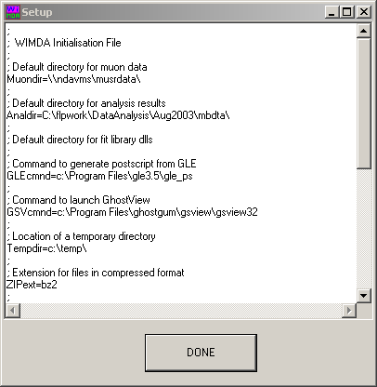

Figure 3.2. WiMDA text-style setup window

3.7 Generating test data

Test data can be created to match a specific fitting function and determine the number of events needed to reach a particular level of accuracy in an experiment. First open the Analyse window and fit the data to a function (see section 7) or, if no data has yet been obtained select the fitting function closest to the theoretical results of the experiment. Select the generate test data command from the File sub-menu and enter the desired number of experimental events in the dialogue box. WiMDA will generate simulated data using the fitting function as a template. The error in fitting the data can be recorded and the number of experimental events increased until a suitable accuracy in the fitted parameter is reached.

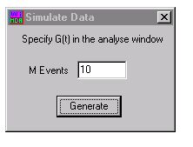

Figure 3.3. Generate test data dialogue box.

4. Logbook

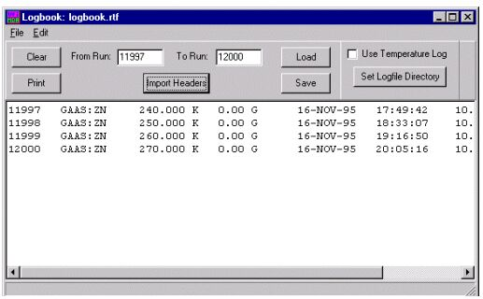

Figure 4.1. WiMDA Logbook Window

A logbook containing the run number, type of sample, temperature, magnetic field, date, time and number of events recorded in a particular set of experiments can be created using the logbook window. Enter the first and last run numbers in the set of experiments in the From Run and To Run boxes. Additional data can be included from the temperature sensors by checking the Use Temperature Log box. The temperature log file is read and an average temperature is calculated for the run (this relies on the temperature log having been saved.) To create a log book click on Import Headers. Logbooks can be printed, saved, loaded or cleared using the button on the logbook window or the commands on the File sub menu. The Edit command menu contains the commands cut, copy, paste and delete for working with contents of the logbook. The Set Logfile Directory is used to set the location where the temperature log files are to be read from. The default is the Tlog subdirectory of the data directory.

5. Grouping

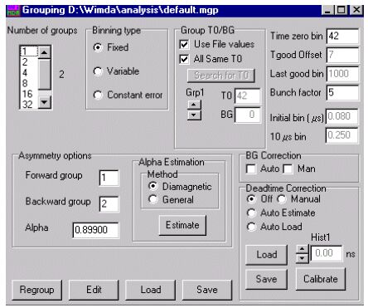

Figure 5.1. WiMDA Grouping Window

The detectors can be assigned to a number of groups from 1 to 32 using the Grouping menu.
The number of actual detectors on ISIS instruments ranges from 32 to 192, other facilities have different numbers, often much fewer.

Where the number of detectors is greater than 32 pregrouping of detector channels is used to give 32 pseudo-detectors. For ARGUS with 192 detectors the pregrouping factor is six and this is done by the acquisition system. Since Autumn 2004, MuSR has increased from 32 to 64 detectors, but pregrouping by a factor of two brings it back to 32 detector channels for WiMDA.

For longitudinal work, the default grouping is usually two groups of detectors one labelled forward and one labelled backward. The grouping of the detectors is saved in the grouping table, which can be edited, loaded or saved to a file using the relevant buttons on the grouping window. Once the grouping has been set up for a series of runs on a particular instrument it should be saved as ‘default.mgp’ in the appropriate analysis directory. This ensures that the default grouping is picked up again when any further analysis is done using this directory.

5.1 Standard groupings

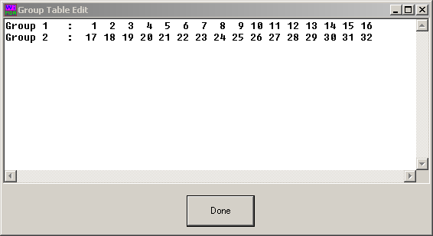

Figure 5.2 WiMDA Group Table showing forwards and backwards groups, as appropriate for a typical ISIS instrument configured for longitudinal relaxation.

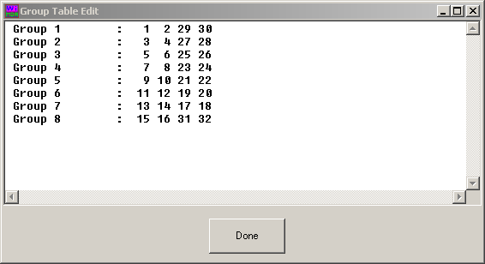

Figure 5.3 WiMDA Group Table showing eight groups, as might be appropriate for transverse field muon spin rotation studies(ISIS MuSR instrument in transverse setup).

5.2 Alpha

The asymmetry is determined by the difference in positron counts between the forwards and backward detectors. The factor alpha compensates for the difference in efficiency between the two detectors. Alpha is used in the expression for asymmetry
a = (F-αB)/(F+αB)
where F and B are the counts in the forwards and backwards detector sets.

5.3 How Alpha is calculated

An estimate of alpha can be made from measuring the precession of diamagnetic muons in a transverse field and then clicking on estimate in the alpha estimation box.
The two methods WiMDA uses to calculate alpha are detailed in appendix A.

5.4 Binning

The muon data acquisition system does not produce a continuous series of time values for positron events. Instead results are group together in amounts of time that are a fixed length long, “ bins”. The usual length of a raw bin is 16 ns for ISIS data files. Significantly smaller bins may however be used for RF studies or for data from continuous muon sources.
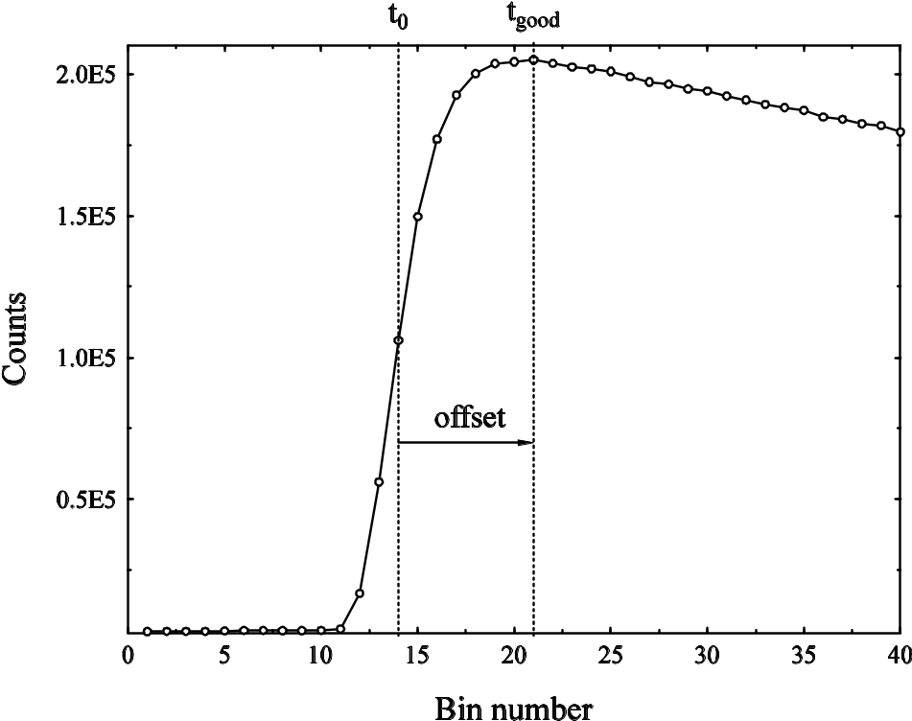

Figure 5.4. Diagram of ISIS data near the pulse showing T _{zero} and T _{good}.

5.5 T zero offset

The difference in time between the timer starting to count and the middle of the muon pulse reaching the sample. At ISIS for example this is typically 0.645 μs (channel 40) for MuSR and 0.278 μs (channel 18) for EMU.

5.6 T good offset

Although the timing origin for the muon response in the sample is when the middle of the muon pulse has reached the sample, the good data region is not obtained until the entire pulse has arrived at the sample. This time is defined as t_{good} and the difference between t_{good} and t₀ is referred to as the t_{good} offset. At ISIS the offset is usually set to seven bins, however for FB analysis t_{good} offset can be made smaller than for transverse field analysis.

5.7 Bunching factor

Several values from different adjacent bins can be averaged together to give just one value which is then plotted.

N.B. the way the data is bunched affects the resulting plot and may affect the fit.

The bunching can be used to create a time average by increasing the bunch factor to specify the length of time that the average is to be taken over. The plot will then automatically display the average value for this time interval. E.g. to create a window 4 μs long the bunch factor should be increased to 250.

5.8 BG (background) correction

Background correction is most important for data from continuous muon sources or when extending data analysis to very long times with pulsed source data. The background signal represents particles detected that are not the decay positrons of muons implanted in the sample. This background signal must be subtracted from the total positron count.
The auto option corrects for the background count by fitting the data to a muon decay plus background and then subtracting the background signal. The manual option sets the background at a constant value, which can be altered by the user. The file option allows another measured run to define the background. The reg option is used for data from continuous sources and defines a region of bins from where the background can be estimated.

5.9 Deadtime correction

After a detector has recorded a positron count there is a small time interval before it is able to detect another count. It is possible that a positron will arrive within this interval and not be recorded. Statistical analysis can be used to correct for this.
The manual mode allows the user to adjust for deadtime for each histogram by scrolling through the histogram numbers and entering the deadtime in the hist dialogue box.
Auto Estimate makes an estimate of the deadtime length and uses this for all histograms.
Auto Load prompts WiMDA to search for a deadtime file in the data directory. (Deadtime files are named dt*. dat. at ISIS). When a silver sample is used for a calibration run the deadtime values can be made into a deadtime file by clicking on calibrate. The file can then be stored and accessed using the save and load buttons. Note that Nexus format data files may have deadtimes stored internally.

5.10 Group T0/BG

Use File values prompts WiMDA to take the grouping information from the grouping files.
All same T0 sets the same value of T0 for all the groups. This is the usual option for ISIS. When this option is switched off the values of T0 can be set for each group individually by scrolling through the group numbers and entering the appropriate value in the T0 dialogue box
When Deadtime Correction is set to manual the background for each group can be set in the same way using the BG dialogue box.

5.11 Binning and Binning type

The default length of a raw bin is 16 ns. If bin length is increased by bunching several bins together the statistical errors in the bin contents decrease.

In Fixed binning the raw bin length is multiplied by the bunching factor to give the final bin size.
For Variable binning the initial bin length and the bin length at 10μs are set and WiMDA interpolates the binning smoothly, based on these reference points.
In Constant Error binning the bin length exponentially increases with time from the initial value so that the counts per bin and the resulting error remain fixed.

6. Plot

6.1 WiMDA plot window
.

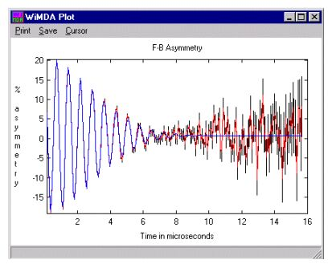

Figure 6.1 WiMDA Plot Showing an Oscillating Signal with Lorentzian Decay.

The data plot can be printed with or without details of the plot and the fit using the Print command. The plot can also be saved as Data, Data with Fit or Fit only via the Save command. A series of plots can also be Batch saved. The saved data is in the form of a text file that can easily be imported into other software. The Cursor can be moved using the arrow keys on the keyboard and used to highlight a specific point on the plot. Batch Add data to Fit Table (see Analysis section 7.12) can be used to put the asymmetry values for a sequence of runs into the fit table.

6.2 Plot parameters window

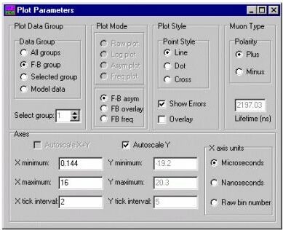

Figure 6.2 Plot parameters window

6.2.1 Plot Data Group

All groups: this plots the output from all detector groups as individual plots.
F-B group: plots only the forward/backward group as defined in the Grouping menu.
Selected group: plots only one group that can be selected by scrolling through the Select Group dialogue box.

6.2.2 Plot Mode

Raw Plot: displays the absolute number of counts versus time.
Log plot: displays the log of the count number versus time. This mode is often used to display data from a single detector to observe the background level or detector problems, as these will produce a plot that deviates from a straight line.
Asym: displays the asymmetry (the raw count divided by the exponential decay of the signal) versus time.
Freq: displays spectral intensity versus frequency. Parameters can be changed using the Fourier window (see section 9.)
F-B asym: displays the forwards/backwards asymmetry.
FB overlay: displays the output from the forwards and backwards detector groups as separate traces on the same asymmetry plot.
FB freq: displays a frequency plot of the forward/backward asymmetry signal. Parameters can be changed using the Fourier window (see section 9.)

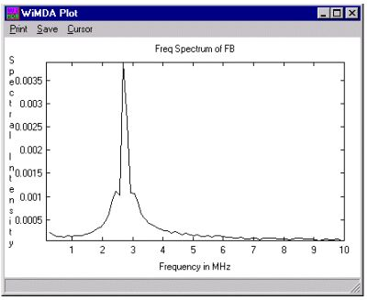

Figure 6.3. WiMDA Plot in the Frequency Domain

6.2.3 Plot Style

The plot can be formatted using the plot style box. The points on the plot can be changed from line to dot to cross. Errors can be displayed or removed from the plot via the Show Errors box. The Overlay box can be checked so the current plot is retained when the next plot is shown so two or more plots can be displayed at the same time

6.2.4 Muon Type

In the Muon Type box the user can specify whether the muons used are positive or negative. The muon Lifetime in nanoseconds can also be changed for negative muons that can undergo nuclear capture.

6.2.5 Axes

The plot axes can be controlled using the Axes box. The axes can be autoscaled or values of the X and Y minimum; maximum and tick interval can be entered. The X-axes units can be selected as Microseconds, Nanoseconds or Raw bin number.

7. Analysis

7.1 Analysis window

The analysis mode in WiMDA allows data to be fitted with up to 3 relaxation components. Each relaxation component is the product of an ‘oscillation’ term and a ‘relaxation’ term.

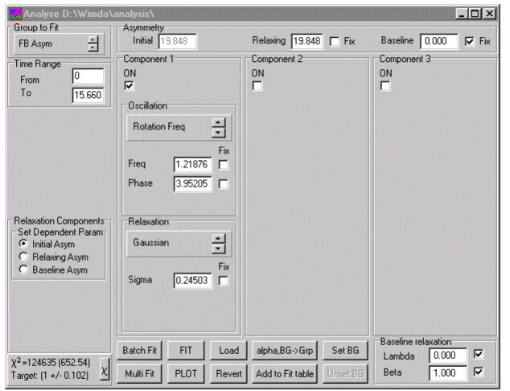

Figure 7.1 WiMDA Analysis window

The standard functions are listed below; many more fit functions are available as fit libraries and users can write their own custom functions.

7.2 Standard Oscillation Functions

None
Rotation Frequency
Rotation Field
Kubo-Toyabe
LF Keren .

7.3 Standard Relaxation Functions

None
Lorentzian
Gaussian
Gaussian2
Stretched Exp.
Risch-Kehr
Gaussian (s^2)
Abragam
Fnorm Str Exp.

(for details of the formulae see appendix C.)

In all functions the frequency parameter is given in MHz and relaxation in μs⁻¹.

All of the variables in the equations for the above fits can be held fixed at a specific value by checking the fix box.

For information on writing custom fit functions see appendix D.

7.4 Group to Fit

7.4.1 FB Asym

Fits plots of the forward /backwards asymmetry

7.4.2 Sel Grp
One group can be selected and fitted. The selected group can be changed in the select group dialogue box in the plot parameters window.

NO is the average count over the plot.
BG is the background count of the plot.

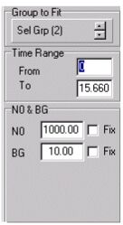

Figure 7.2 Group to Fit Section of Analysis Menu Showing Select Group Option.

7.4.3 F, B

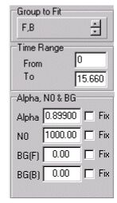
The counts detected by the forwards and backward channels are displayed and can be fitted.
Alpha can be determined from the fit (see appendices.)
NO is the average count between the two channels
BG (F) is the background count for the forward channel
BG (B) is the background count for the backward channel

Figure 7.3 Group to Fit Section of Analysis Menu Showing F,B Option.

7.4.4 All Groups

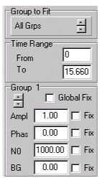
The count from all groups is displayed and can be fitted
Different groups can be selected by clicking on the arrow below Group 1.
The Global Fix function holds a parameter that is declared fixed in one group fixed in all the groups.
Ampl is the amplitude of the oscillation.
Phase is the phase of the individual groups. This is the phase that is fitted in this mode. The phase in the oscillations sub window should be fixed at zero.
NO is the average count in each group.
BG is the background count in each group.

Figure 7.4 Group to Fit Section of Analysis Menu Showing All Groups Option.

In all of the group to fit options there is a Time Range dialogue box which can be used to specify the range of data over which WiMDA will perform the fit.

7.5 Asymmetry and Relaxation Components

The Baseline asymmetry is typically a small modifier of the alpha value to allow accurate balancing of the forwards and backwards detector sets in a forward-backward grouping. It can be found through the fitting of a transverse field run once alpha has been estimated. It should be fixed when fitting longitudinal runs. The baseline asymmetry may also be used to fit a fourth relaxing component where necessary.

The Initial asymmetry is defined as the total asymmetry at time = 0.
The Relaxing asymmetry is defined as the difference between the initial and baseline asymmetries. In the figure below it is the sum of the amplitudes of two components, one relaxing (component 2), and one not relaxing (component 1.)

The asymmetries are related by the equation: Initial - Relaxing = Baseline.

Because of this constraint, not all the asymmetries can vary simultaneously. The user can select which asymmetry parameter will be dependent on the other fitted values in the Relaxation Components box.
Asymmetry

Initial Asymmetry
Relaxing Asymmetry
Component 2

Component 1

0

Baseline
Asymmetry
Time

Figure 7.5 Diagram of Different Types of Asymmetry Components
Similarly, if the fit function has more than one component the Amplitude of each component will be added together to give the Relaxing asymmetry. One of these parameters must again be dependent on the others and the user can select which parameter in the Dependent Amplitude section of the Relaxing Components box.

Clicking on the χ button produces an estimate of the χ² value that the fit function with the entered parameters will have.

7.6 Batch Fit

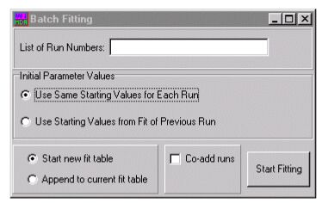

Figure 7.6 WiMDA Batch Fit Window

Batch Fit can be used to fit several plots in sequence.

The Batch Fitting window can be used to enter the run numbers that are to be fitted. The user can also switch between resetting the starting values for the fit in every new run or using the values obtained from the previous fit as the starting values for fitting each run. The latter is recommended for experiments where each gradual changes in the plot take place over several runs.
The fit results can be written to a new fit table or added to the current fit table. The runs can also be co-added.

7.7 Other functions

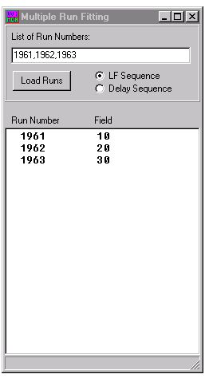
Many runs can be fitted to the same parameters using the Multi function. This is done by clicking on the Multi Fit button in the Analysis window. The run numbers to be fitted should then be listed in the multi fit dialogue box. When analysing a LF series of runs, WiMDA will list the fields of the individual runs and display each set of data on the same plot,. All the sets can then be fitted simultaneously using the fitting functions in the Analysis window.

Figure 7.7 WiMDA Multi-fit Dialogue Box

Fit parameters can be extracted from previous fit logs by clicking the Load button. (The same function must be selected for this to work.)

The Revert button resets the fit to the previous fit parameters. This is often useful if WiMDA has been unable to fit the data as it allows another attempt to be made with different starting values for the fit parameters.

Alpha, BG -> Grp allows the alpha value obtained from the fit of the data to be used in the current fitting and stored in the Grouping file if the value is saved
Add to Fit Table writes the details of the plot and fit to the fit table.

Set BG takes the current fit function and saves it as the background function and then subtracts the function from all subsequent fits.

7.8 Baseline Relaxation

The baseline relaxation is taken to be a stretched exponential function. The values of lambda and beta can be held fixed by checking the boxes, or entered manually into the dialogue boxes.

7.9 Linking

It is also possible to link two parameters together by clicking on the parameter title. A link window is brought up and parameters can be added to different linked groups e.g. to link the values of lambda for the Lorentzian relaxation of two functions and add them to the same link group. This would be done by clicking on the word lambda and then clicking on the group the parameter was to be added to.

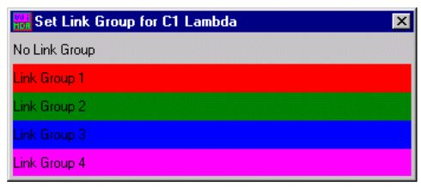

Figure 7.6 WiMDA Linking Window

When the analyse menu option is selected on the main window, in addition to the main analysis window, a fit table and a fit log are also automatically brought up.

7.10 Fit Table

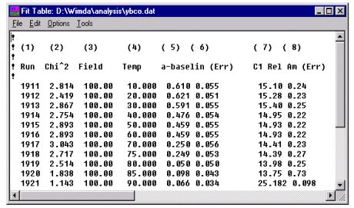

Figure 7.9 WIMDA Fit Table

The fit table records the final values of the fit parameters and basic information about the experiment, the run number, temperature and magnetic field during the experiment. By clicking on add to fit table in the analysis window after the fit has been completed the results of a fit can be added to the fit table.

Fit Tables can be Saved, Loaded and Printed using the File sub menu on the Fit Table window. New fit tables can also be created. The fit table can edited using the Cut, Copy, Paste and Delete command on the Edit sub menu. The Options sub menu allows the user to select whether the run temperatures are taken from the temperature logs or the data entered by the user. The Tools sub menu gives the user the option of calculating and displaying column averages, sorting the table in order and refitting data using the co-adding of runs specified by some rebinning criterion.

7.11 Fit Log

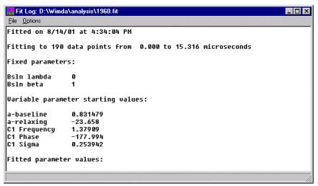

Figure 710 WiMDA Fit Log

- The Fit Log records all the fit parameters including which parameters where fixed and the initial and final values of any parameters left unfixed. A value of chi-square for the fit is also recorded.
- A user can load, save or print the fit log using the commands on the File sub menu.

7.11.1 Fit Options

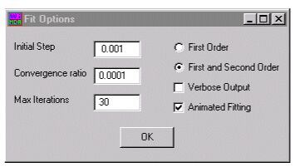

Figure 7.11 WiMDA Fit Options Dialogue Box

- Animated Fitting shows the fit changing over time.
- Verbose Output displays more information about the fit. Parameter details are given for every iteration.
- The user can select whether WiMDA uses a First Order or First and Second Order extrapolation in the fitting routine. The first order extrapolation may be helpful for fitting some types of noisy data.
- The Initial Step is the amount by which the parameters are altered in each iteration.
- The Convergence Ratio is the number of decimal places all the parameters have to converge to before a fit is reached.
- A maximum number of iterations for WiMDA to attempt can also be set.

7.12 Batch add to fit table using a cursor.

WiMDA can also create tables of how one specific point on a plot varies over several experiments. This is done by selecting the cursor to visible on the plot window and adjusting it to the desired position using the arrow keys on the keyboard. Then batch add to fit table can be selected from the cursor sub menu. A dialogue box to fill the start and end run numbers automatically appears. WiMDA can create a log table where each row contains a run number, the temperature and field of the run and the asymmetry at the point where the cursor was positioned. By plotting different columns of the table it is possible to produce a plot of asymmetry as the function of variable such as temperature. This would be done by performing a “batch add to fit table” of several runs of varying temperature and then plotting the temperature and asymmetry columns of the table.

These functions are particularly useful for Level Crossing Resonance (LCR) and RF data file sequences.

8. Model

Model is used to display and fit parameters generated from fits to data sets. Parameters are taken from WiMDA fit tables and typically represent temperature or field dependent parameters derived from fitting series of runs.

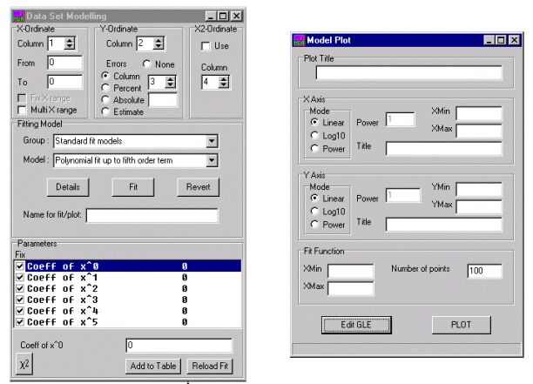

Figure 8.1 WiMDA Model Windows

8.1 Data Set Modelling

The user can specify which column from the Fit Table to use as the data for the x values, y values and errors on the model plot. WiMDA will automatically take the entire range of column values to be the data range but this can be altered by editing the values in the From and To dialogue boxes.

8.1.1 Fitting Model

The user can select model functions to fit to the data by selecting the appropriate fitting library in the Group dialogue box and then selecting one of the functions in the Model dialogue box. Clicking on FIT starts the fitting. (For information about creating custom functions see appendix D.) The user must enter a name for the plot in the Name dialogue box or WiMDA will be unable to create a model plot.

8.1.2 Parameters

All of the parameters is the model fit are listed in the dialogue box. Any of the parameters can be fixed by checking the fix box. When a parameter is clicked on its value comes up in the smaller dialogue box and can be edited.

The χ² field is updated after each fit and the χ² button can be used to given an estimate of the chi-squared value for the fit with the parameters set at their present value. The value in brackets after the χ² value is χ² normalised by the number of degrees of freedom. This should approach one if the errors are correctly estimated and the fit is good. If the number of data points is small and the statistical error on the data is large then the variance on χ² at the fit may be large. The χ² target field provides an indication of the expected deviation of the normalised χ² from unity in the current fit.

8.2 Model Plot

The user can use this window to give their plot a title and format the x and y-axes. The scale of the axes can be set to Linear, Log10 or Power and the Axes given a Title and the range of the axes set. The range of the fit function can also be set in the Fit Function box. Pressing the Plot button produces the plot as a postscript file which will be displayed by the GhostView utility. For an example of creating a model plot see Example Experiment.

The plot is generated using a plot scripting language called GLE. Fine tuning of the plots produced (e.g. font style, size, labels, adding extra data sets, inset plots etc.) can be done by clicking the Edit GLE button to bring up the GLE Window.

8.3 GLE Window

As well as being brought up by the Edit GLE button in Model Plot this window can also be accessed through the GLE entry in the Plot submenu of the Main Window. E.g.:

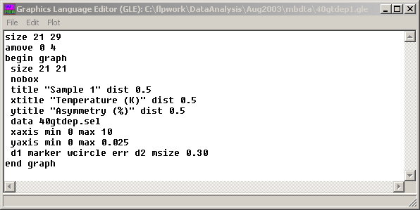

The GLE Window is a simple text editing window. Fine tuning of the GLE code can be used for specification of overall plot size, fonts, labels etc. and GLE can also be used to build up much more complicated multiple plots. For example to plot two data sets on the same graph the above GLE code could be modified as follows:

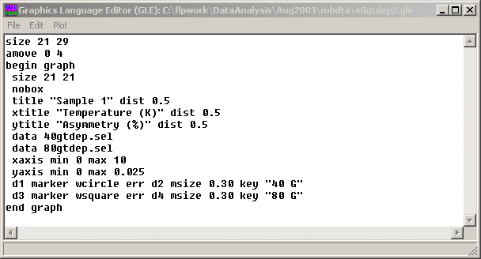

Full details of the many commands available in GLE and their corresponding syntax are given in the separate GLE manual.

9. Fourier

Transformation into the frequency domain is controlled by the Fourier window.

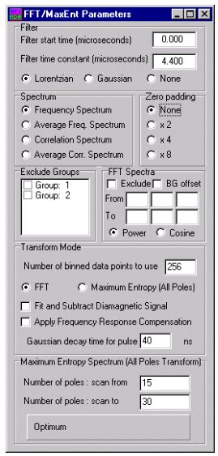

Figure 9.1 WiMDA Fourier Window

A Fourier transform of the data can be obtained by checking the FFT box. Prefiltering (apodization) of the data is needed to control the balance between frequency resolution and noise in the spectrum. The filter can be Lorentzian, Gaussian or switched off and a delayed start can also be specified in the Filter sub section.

Zero padding is a method of smoothing the spectrum by adding extra null points after the real data just before transformation to allow a higher resolution transform to be used.

It is possible to obtain the average of the Fourier transforms of the signal from each detector group by clicking on Average Freq. Spectrum. It is also possible to exclude the signal from one or more detector groups via the exclude groups sub menu. Specific parts of the spectrum can also be removed using the exclude function in the FFT Spectra sub menu.

In experiments where both paramagnetic and diamagnetic signals are present the diamagnetic signal can be removed by clicking Fit and Subtract Diamagnetic Signal. The correlation spectrum option can then be used to produce a plot of the spectrum as a function of hyperfine interaction from which information about the coupling of the muon and electron can be obtained.

WiMDA assumes the muon pulse to be a Gaussian with a specific decay time which leads to a high frequency cut-off in the frequency response. It is possible to make some compensation for this by dividing the transform by the Gaussian function, the Frequency Response Compensation option.

An alternative transform to the frequency spectrum of the data can also be obtained, using the method labelled ‘maximum entropy / all-poles transform’. This type of transform is often better than the FFT for spectra containing a series of sharp frequency peaks. The number of poles used can be selected to cover a range in the Maximum Entropy Spectrum sub window and WiMDA will automatically calculate the optimum number. The number of poles should be < ½ the number of data points. This one-step transform method should be distinguished from another method of spectral estimation also running under the name ‘maximum entropy’, which reconstructs the frequency spectrum iteratively using maximum entropy principles.

In all cases increasing the bunching factor reduces the frequency range and increasing the number of bins used increases the frequency resolution.

10. Using WiMDA to analyse PSI data

WiMDA can automatically interpret the structure of different data files; therefore results from PSI can be loaded into WIMDA in the usual way.

It is recommended that the search for T0 function in the Group menu is used to find an accurate value for T0 and T good offset is set to approximately 3. Because PSI is a continuous muon source the number of background positron counts is much greater than at ISIS. To reduce the effect of this it is recommended that the background is calculated from fitting actual data and the result sent to the Group window using the alpha, bg → group command on the Analysis menu. Alternatively, the background can be calculated using the region method, in which WiMDA estimates the background from the counts recorded before T good.

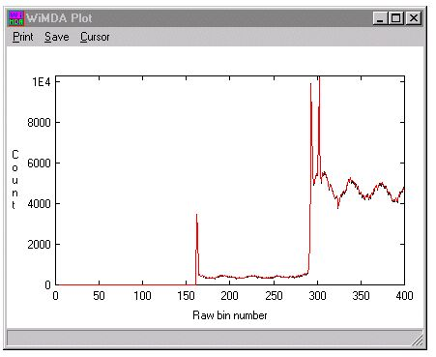
Tgood
T0

Region of background counts B1 to B2

Figure 10.1 Plot of Count Rate as a function of Raw Bin Number Showing T0 and T good

One of the main differences between PSI and ISIS is that PSI has far fewer detectors. For this reason it is logical to analyse each detector individually as its own group and select specific forward and backward detectors for asymmetry plots.

11. Example Experiments

11.1 Example experiment 1: Longitudinal Fields

A typical experiment might consist of a T20 followed by longitudinal runs at different magnetic field strengths and temperatures. In this example a set of runs from a copper sample were used. (MuSR runs 01948 to 01958.)

Begin by loading in a T20. The plot of the data will automatically be brought up with the plot parameters and groupings window. The T20 run allows alpha and the baseline to be found for the subsequent longitudinal runs. Once alpha and the baseline values have been found from the T20 run, do not change them for longitudinal runs (make sure the fix box by the baseline is ticked.)

Ensure the grouping table is set to the desired configuration. Click on estimate to obtain a value for alpha, which can be fixed and used throughout the whole set of runs. Set bunch factor to an appropriate value.

Scale the plot axes to an appropriate length and select plot mode in the plot parameters window.

To fit the T20 run more precisely, to get the baseline value, click on analyse in the WiMDA main menu. Select a component and relaxation function to fit the data to. The copper runs were fitted with a single oscillating component with Gaussian relaxation.

Enter approximate values for fit parameters wherever possible.

For a T20 run allow the baseline to vary. The baseline acts as a small correction to the approximate alpha value estimated earlier.

Click on FIT.

The results of the fit are displayed in the fit log window. If the fit is not acceptable return to the analyse window retry the fit with a different fit function and/or relaxation.

If WiMDA was unable to fit the data the values of the fit parameter can be reset using the revert button in the analyse window.

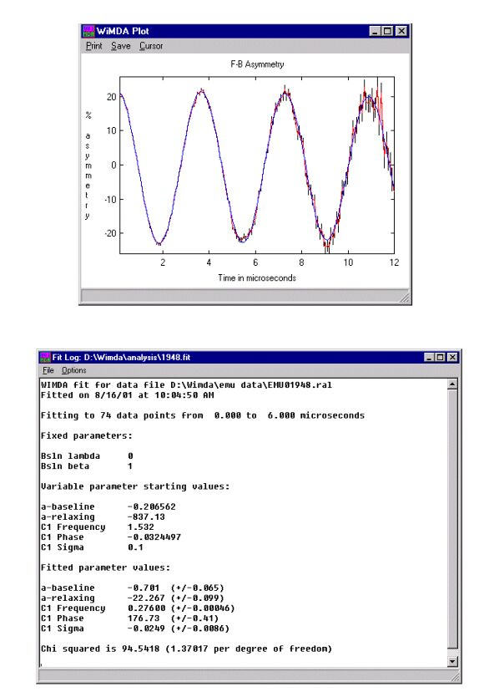

Figure 11.1 Plot and Fit Log for a T20 Run

Then begin analysing the longitudinal runs. To load the next run number in click on load >> or << load in the WiMDA main menu. Alternatively scan for the desired run number using the step >> or << step buttons. Load the run.
Set plot axes to an appropriate scale.

Select fit functions and estimate starting values. The copper data was found to fit to a Kubo Toyabe function

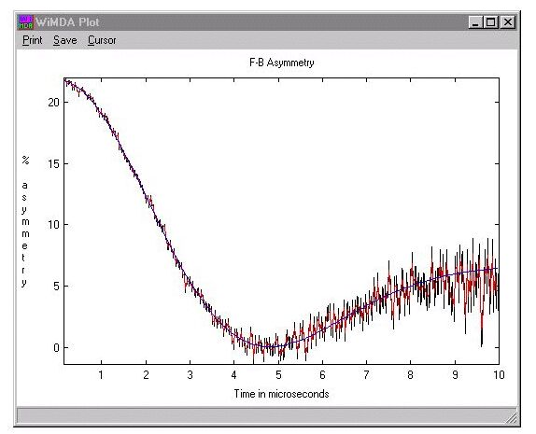

Figure 11.2 Decrease of muon polarisation in a zero field at 20K

Now fit the data.

If there are multiple runs that are to be fitted to the same function, the batch fitting option can be used (see section 7.6.)

When an acceptable fit is obtained the results can be added to a fit table by clicking on add to fit table in the analyse window.

Study of cross relaxation using the batch add to fit table function

Depolarisation can occur when muons are in a material where the separation of energy levels of nuclear spins in the material are the same as the separation of muon energy levels. For quadrupolar nuclei this matching condition can always be satisfied at one or more values of magnetic field. A resonant depolarisation will occur at these particular magnetic field values, that can be observed as a dip in the time-average muon polarisation as a function of field. WiMDA can produce time-averaged polarisation values using a large bunching factor (see section 5.7.) Use of the cursor and its batch mode allows time-averaged values from a series of longitudinal field runs to be generated. This can be studied using the batch add to fit table in WiMDA to process a series of longitudinal field runs.

Load and plot the first longitudinal run in the experiment.

In the grouping menu increase the bunch factor to create a time window of desired duration e.g. to create a window 4 μs long the bunch factor is increased to 250.

In the plot window set cursor to visible and place the cursor on the point on the plot to be studied using the arrow keys on the keyboard.

On the cursor sub menu select batch add to fit table. Enter run numbers to be studied. A fit table of the information contained in the plots is automatically produced.

Creating a model plot

Open the model windows. Select the column containing the magnetic field values as the column in the x-ordinate box and the column containing the asymmetry values as the column in the y-ordinate box. Give the plot a title and label the axes.

Press plot. A ghostscript plot of the data is produced and can be opened in ghostview. Alternatively the fit table can be exported as an ASCII file and the plot created in another program such as Excel or Origin.

An example of a plot of cross relaxation in copper where several time windows are studied is shown below. The bunching factor used is 250 for the 0-4, 4-8 and 8-12 μs time windows and 750 for the 0-12μs time window.

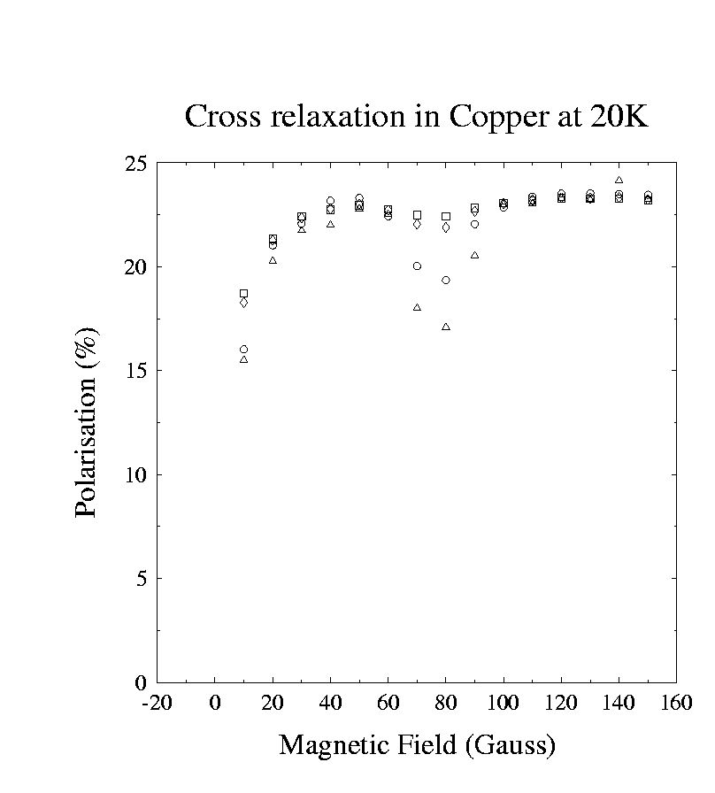
0-4 μs
4-8 μs
8-12 μs
0-12 μs

Figure 11.3 Cross Relaxation in Copper at 20K

11.2 Example experiment 2: Transverse Fields

μSR techniques are also often used to observe muon ionisation. A sample of ZnO was placed in a transverse field at room temperature and the muons in the sample were observed to precess. (MuSR data 37713 to 37759.) This suggested the muons had thermalised as the positive ion. Below 40K a beating pattern appeared in the muon frequency plot, showing the presence of two further signals, the frequencies of which were symmetrical about the Larmor frequency. These signals were due to the hyperfine interaction with an unpaired electron spin weakly bound by a muon. ⁽¹⁾
The amplitudes of these signals can be plotted as a function of temperature. The Larmor frequency and the two outlying frequencies have a logarithmic relationship with inverse temperature between around 30K and 40K. It is possible to create an Arrhenius plot of this region and determine the activation energy of the muon from the gradient of the plot.

Begin by loading the first run number.

Because the experiment uses a transverse field the transverse grouping table should be loaded via the grouping window

Set plot axes to an appropriate scale.

Select fit functions and estimate starting values. The ZnO data was found to fit to three oscillating functions with Lorentzian relaxation.

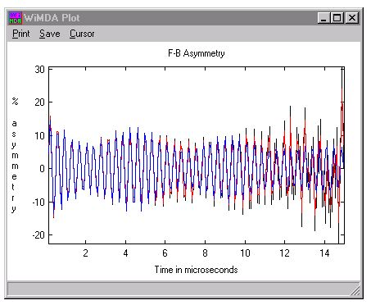

Figure 11.4 WiMDA plot of the beat frequencies in ZnO at 200G and 17.5K

When a satisfactory fit of the data is obtained add the fit data to the Fit Table using the Add to Fit table button on the Analyse window.

Once the fit table contains all the data, switch to the Model window, define the temperature column as the x-ordinate and the asymmetry and its error as the y-ordinate column. The data should fit to the linear equation ln y = -E_{A}/kT (where is E_{A} the muon activation energy, k is Boltzman’s constant and T in absolute temperature). The standard model library has a thermal activation model that can be used to fit the data and derive the activation energy.

To plot the data and the fit in the form of a standard Arrhenius plot set X-Axis mode to power and the power to -1 in the Model Plot window and set the Y-axis mode to Log10.

Alternatively, after having inserted fitting results into the Fit Table it can be imported into Excel, Origin or similar program which can be used to plot asymmetry as a function of inverse temperature and estimate the activation energy from the Arrhenius plot.

1. Experimental confirmation of the predicted shallow donor hydrogen state in zinc oxide, S.F.J. Cox et al, Physical Review Letters vol. 86 no. 12, 19 March 2001.
12. Troubleshooting

Negative frequency

This is caused by the phase being 180º too large. To correct this problem, simply delete the minus sign from the frequency, alter the phase by 180º, and fit the data again.

WiMDA unable to fit data

To improve the chances of WiMDA producing a good fit, enter approximately correct values of any fit parameters possible as starting values for the fit.

A poor fit may also be caused by an incorrect grouping file being used. To correct this edit the grouping table to the desired configuration and click on regroup.

The bunching factor, which can be controlled via the Grouping window, may also strongly affect the fit of the data.

WiMDA unable to produce a model plot of data

Ensure the plot has been given a title in the Data Set Modelling window and that the environment variable gle_top is set to the root directory where gle is installed and the correct command line invocation (e.g. c:\gle\gle_ps.exe) is listed in the wimda.ini file.

Ensure Ghostscript and Ghostview are correctly installed.

Appendices

A. Alpha calculation

A rough estimate of alpha can be obtained using the diamagnetic alpha estimation in the groupings window. In this method the forward and backward asymmetries are added together. When alpha is correct the asymmetries should add up to zero. WiMDA goes through an iterative process to find the value of alpha that produces the closest result to zero.

In the general alpha estimation method the forward and backward asymmetries are treated as separate functions and added together. When alpha is correct the resulting function should be constant as the forward and backward variations will cancel exactly. WiMDA goes through an iterative process to find the value of alpha that produces the closest result to a constant.

The most accurate way to obtain a value of alpha is select F,B in the Group to Fit sub menu of the analysis menu. This allows alpha to be fitted as a plot parameter. The value of alpha obtained can be stored in the groupings menu by clicking on Alpha, BG >group button on the analysis menu.

B. Deadtime correction

A calibration run using a silver sample is performed in each cycle. The dead times are calculated from this run and stored in a file which is automatically read in to the results file.

C. Standard Fit functions

Oscillation

Rotation frequency F(f,φ,t) = cos(2π(ft+φ/360))
Rotation field F(B,φ,t) = cos(γ_{μ}Bt+π φ/180)

Kubo-Toyabe:

1) Static Zero Field F(Δ,t) = 1/3 + 2/3(1-γ_{μ}²Δ²t²) exp (-1/2γ_{μ}²Δ²t²)

2) Finite Field F(Δ,B,t) = 1-(2γ_{μ}²Δ²/ω_{o}²)[1-exp(-1/2γ_{μ}²Δ²t²)cosω_{o}t] +(2Δ⁴/ω_{o}³)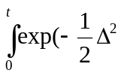τ ² )sinω_{o}τdτ
3) Dynamic F(Δ,B,ν,t) = ν^{n}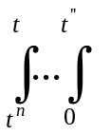dt^{(n)} … dt’ g(t- t^{(n)} )… g( t’ )exp^{-νt} g(t) is the static Kubo-Toyabe function F(Δ,B,t)

LF Keren F(Δ,B,ν,t) = {2Δ²/(ω_{L}² + ν²)²}.((ω_{L}² +ν²) νt + (ω_{L}² - ν²) (1-e^{νt} cos(ω_{L}t)) -2 ν ω_{L} e^{-νt} sin(ω_{L}t))

ω_{L} is the muon Larmor frequency γ_{μ}B

Relaxation

Lorentzian G(λ,t) = exp(-λt)

Gaussian G(σ,t) = exp(-σt)²
Gaussian 2 G(σ,t) = exp(-σt/2) ²
Gaussian (s^2) G(s2,t) = exp(-s2 t²)

Stretched Exp. G(λ,β,t) = exp(-λt)^{β}

Abragam
1) transverse G(σ,τ_{c},t) = exp{-2σ²τ_{c}² [exp(-t/τ_{c})-1+ t/τ_{c}]}
2) longitudinal G(σ,τ_{c},t) = exp{-σ²τ_{c}² [exp(-t/τ_{c})-1+ t/τ_{c}]}

Risch-Kehr G(Γ,t) = exp(Γt) erfc (Γt)^{1/2}
Fnorm Str Exp. G(λ,f,t) = exp(-λft)^{β}

D. Writing Custom WiMDA Functions

To write fit or model functions a 32 bit Borland Delphi Pascal compiler is required (version 2 onwards). Templates of functions can be downloaded from http://www.isis.rl.ac.uk/muons/data%20analysis/index.htm (files musrfunctions.dpr, musrfunctionunit.dcu, and depending on the version of Delphi used also musrfunctionunit.pas.) These functions are written in Delphi but it is hoped that in future editions of WiMDA templates will be available in other languages e.g. C and Fortran.

Once downloaded the functions can be edited to the desired specification and compiled. The model function library should then be stored in the same directory as WiMDA under the name *fit.dll. If the user wishes it is possible to write a dynamic link library in a language other than Delphi, for example Fortran or c; information about the required functions and calling conventions can be found in the source code units musrfunctionunit.pas and userunit.pas.

Example 1. Custom Analysis functions.

A segment of code downloaded from http://www.isis.rl.ac.uk/muons/data%20analysis/index.htm file musrfunctions.dpr.

function LorRel(t,p1,p2,p3,dum : double):double; stdcall;
begin
LorRel:=ex(-p1*t);
end;

function GauRel(t,p1,p2,p3,dum : double):double; stdcall;
begin
GauRel:=ex(-sqr(p1*t));
end;

To add another function, simply define a new one following the same template

e.g.

function MyNewFunction(t,p1,p2,p3,dum : double):double; stdcall;
begin
MyNewFunction := 1-p1*t;
end;

Then go to the initialisation code to insert a link in the list of functions:

relfirst;
relsetname('Lor reln');
relsetfunc(LorRel);
relsetpar('Lambda(MHz)');
relsetdesc('Lorentzian relaxation');
relnext;
relsetname('Gau reln');
relsetfunc(GauRel);
relsetpar('Sigma(MHz)');
relsetpar('Dummy1');
relsetpar('Dummy2');
relsetdesc('Gaussian relaxation');
.....

Insert the following lines in the list:

relnext;
relsetname('My new function’); { name that will be displayed in the function list}
relsetfunc(MyNewFunction); { link to the actual function}
relsetpar(‘Slope'); {first parameter name}
relsetpar(' name of 2nd parameter '); {needed if there is a second parameter}
relsetpar(' name of 3rd parameter’); {needed if there is a third parameter}
relsetdesc(‘description of function'); {helpful reminder text}

Compile and build the project (project menu → compile musrfunctions → build musrfunctions) with the file musrfunctionunit.pas. This will generate a file musrfunctions.dll. Ensure that the analyse window is not open and transfer the dynamic link library created to the directory where WiMDA is run from or where fit libraries are searched for. When the analyse window is restarted the new function will be included as an option in the list. This example is for a relaxation list function, an oscillation list function is added in a similar way, see the template code for details.

Example 2. Custom Model Functions

A very similar method is used to write custom functions to fit model data.

Files required: userfit.dpr. This needs to be linked with userunit.dcu. Depending on the version of Delphi userunit.pas and fittyps.pas may also be required. All files can be downloaded from http://www.isis.rl.ac.uk/muons/data%20analysis/index.htm file userfit.dpr.

function example1(x:double; x2:double; p: array of double): double; stdcall;
begin
example1:=p[3]+p[2]*x+p[1]*sqr(x)
end;

function example2(x:double; x2:double; p: array of double): double; stdcall;
begin
example2:=p[1]+p[2]*power(x,p[3])
end;

To add another function, simply insert it following the template below into the list of functions.

function MyModel(x:double; x2:double; p: array of double): double; stdcall;
begin
if x>0 then Mymodel:=p[1]*exp(-p[2]/x) else MyModel:=0;
end;

Then go to the initialisation section:

firstfunc;

setname('Quadratic fit');
setfunc(example1);
setpar('a');
setpar('b');
setpar('c');
setdesc('Quadratic fit: y = a x^2 + b x + c');

nextfunc;

setname('Power law fit');
setfunc(example2);
setpar('a_const');
setpar('a_power');
setpar('n');
setdesc('Power law fit: y = a_const + a_power x^n');

Insert information on the new model function into the list:

nextfunc;

setname('My Latest Model');
setfunc(MyModel);
setpar(‘Amplitude');
setpar(' Ea ');
setdesc(‘Simple activation law');

Compile and build the project to make the dll file userfit.dll. Make sure the Model window is closed and place in the fit library directory. When the Model window is next opened the new model function will be available for fitting with.
Index

χ², 40
Abragam, 27
Add to Fit Table, 33
All groups, 23
All same T0, 21
Alpha calculation, 54
Alpha estimation, 19
Alpha, BG -> Grp, 33
Animated fitting, 36
Asym, 23
Asymmetry, baseline, 30
Asymmetry, initial, 30
Asymmetry, relaxing, 30
Auto background correction, 20
Auto Estimate deadtime correction, 21
Auto Load deadtime files, 21
Average frequency. spectrum., 43
Axes, 24
Baseline relaxation, 34
Batch Fit, 32
BG (background) correction, 20
Binning, 19
Binning, constant error, 21
Binning, fixed, 21
Binning, variable, 21
Bunching factor, 20
Calibrate deadtimes, 21
Co-add, 10
Compressed data files, 13
Convergence ratio, 37
Copper example experiment, 45
Correlation spectrum, 43
Co-sub mode, 11
Cursor, 22, 37
Custom analysis functions., 56
Custom model functions, 58
Data set modelling, 40
Deadtime correction, 54
Deadtime correction., 21
Decompress command, 13
Default directory for analysis results, 12
Default directory for muon data, 12
Dependent Amplitude, 32
Diamagnetic frequency signal, 43
Directory, 9
Downloading WiMDA, 7
Events, 9
Example experiments, 45
Exclude groups, 43
F-B asym, 23
FB freq, 24
F-B group, 23
FB overlay, 24
FFT, 42
FFT spectra, 43
First and second order extrapolation, 37
First order extrapolation, 37
Fit Log, 36
Fit table, 35
Fitting model, 40
Fnorm Str Exp., 27
Freq, 23
Frequency response compensation, 43
From run, 16
Gaussian, 27
Gaussian (s^2), 27
Gaussian 2, 27
GhostView, 13
GLE, 40
GLE window, 41
Grouping, 17
Histograms, 8
Initial step, 37
Kubo-Toyabe, 27
LF Keren, 27
Linking parameters, 34
Load fit Libraries, 11
Log plot, 23
Logfile Directory, 16
Lorentzian, 27
manual background corection, 20
Manual deadtime correction, 21
Maximum entropy spectrum, 43
Maximum number of iterations, 37
Model parameters, 40
Model plot, 40
Multi fit, 33
Muon Lifetime, 24
Muon type, 24
Open, 11
Overlay, 24
Plot style, 24
Plot window, 22
Postscript from GLE, 13
Printer set-up, 11
Problem, negative frequency, 53
Problem, unable to fit, 53
Problem, unable to plot model fit, 53
PSI data, 44
Raw Plot, 23
Relaxation Components, 30
Revert, 33
Risch-Kehr, 27
Rotation Field, 27
Rotation Frequency, 27
Run Number, 8
Save/ Save as, 11
Saving WiMDA plots, 22
Search for T0, 44
Selected group, 23
Set BG, 33
Set up, 12
Show Errors, 24
Standard fit functions, 55
Standard groupings, 18
Step, 10
Stretched Exp., 27
T good offset, 20
T zero offset, 20
Time filters, 42
Title, 8
To run, 16
Use Temperature Log, 16
Verbose output, 36
Windows 2000/XP, 7
Windows 95 and 98, 7
Windows NT, 7
Zero padding, 42
ZnO example experiment, 50

